The Kapil Forex & Tours Pvt. Ltd. Report

PRESENT BY:

Akash Sejpal

SUBMIT-

Mr. Brijesh Khodasir



SHASTRI SWAMI SHREE

DHARMAJIVANDASJI INSTITUTE OF

INFORMATION TECHNOLOGY

YEAR (2019-2020)



Preface

Our project is developed using PHPand MYSQL SERVER Tools and technology that is server-side language.

Our Project Code Is Totally PHPBase.

Our Project entitles The Kapil Forex & Tours Pvt. Ltd. Package booking system.

We developed our project in English Language so that everyone has no difficulty for accessing Web Application.

It is our great pleasure to present our project report on “The Kapil Forex & Tours Pvt. Ltd.” which we conceived the 5th Semester of BCA affiliated to BKNMU , Junagadh.



Acknowledgement

We are very thankful to all, who have helped us in preparing this project. We are much happy to present this “PROJECT REPORT”. Before you, expecting that you will acknowledge. It is the matter of great pleasure for me. As a part of the academic study as the student of 5th semester of BCA.

We are required to undergo training for website project to the organization in order to obtain the practical knowledge and broaden our view regarding the same.

As first, we would like to express our humble thanks and gratitude to the Evalutor of SSSDIIT Mr. Brijesh Khoda who has provided us such a great co- operate as progressive environment. Secondly, at the moment, we would like to express our deepest sense of gratitude to our deepest of Mr. Brijesh Sir. Who have contributed us the required information with special interest and guidance throughout our project work and treated us as their younger brothers.

We are indebted to all the people of our collage, SSSDIIT College, concerned, who have actively involved in marking of the project. Last but not the least we would thanks the god who has made us to do the project & also our parents without their support we would not be able to complete the project successfully.

|  |  |  |
| --- | --- | --- |
| NO. | Index | Page No. |
| 1 | Project Profile | 5 |
| 2 | Requirement | 6 |
| 3 | Feasibility Study | 8 |
| 4 | Hardware Requirement | 10 |
| 5 | Software Requirement | 11 |
| 6 | Data Dictionary | 12 |
| 7 | Data-Flow Diagram   * DFD 0 LEVEL * DFD 1 LEVEL   1. Client Side   2. Admin Side * DFD 2 LEVEL   1. Client Side   2. Admin Side | 16 |
| 8 | PERT Chart | 21 |
| 9 | GANTT Chart | 23 |
| 10 | Testing   * Black Box Testing * White Box Testing * Grey Box Texting | 25 |
| 11 | All Screen Layout | 26 |
| 12 | Biblography | 45 |



Project Profile

|  |  |  |
| --- | --- | --- |
| Project Title | :- | “The Kapil Forex & Tours Pvt. Ltd.” |
| Project Type | :- | Website |
| Front-End | :- | CSS , Javascript , Jquery , Bootstrap |
| Back-End | :- | PHP , MYSQL |
| Time Duration | :- | 3 Months |
| Team Size | :- | 1 Member  ➢ Akash Sejpal |
| Stream | :- | BCA Sem 5th |
| Academic Year | :- | 2019 |
| Collage Name | :- | Shastri Swami Shree Dharmajivandasji |
|  |  | Institute Of Information Tchnology – |
|  |  | JUNAGADH. |
| Project Guide | :- | Mr. Milind Anandpara |
| Project Evalutor | :- | mr. Brijesh Khoda |
| Project Submission | :- | Bhakta Kavi Narsinh Mehta University |
|  |  | - JUNAGADH. |

Requirement



* This project used for tours management system.
* This project contain following modules:-
  + Home
  + About
  + Tourpackages
  + Privacypolicy
  + Terms of use
  + Contactus
  + Enquiry

User Side:-

* This information about “Kapil
* Forex & Tours Pvt. Ltd.” Should be display in home page.
* The images , package list & information about display wise to all visitors.
* Only register user must book the packages.
* The select package by register user should be added to “Book”.

Admin Side:-

* All information about registered users should be handled by admin.
* All packages should be displayed & deleted by admin.
* Admin can modify gallery & videos.
* Admin can create & manage the tour packages.
* Admin can see booked tours.



Feasibility Study

1)Economical Feasibility:-

* Consider the user need for a tours packages , the cost of designing and development cost around Rs.8000,it also converts the cost of internet access , domain and hosting.
* The cost of internet connection around Rs.2000,the cost of domain around Rs.1000,the cost of hosting around rs.1000.the total cost of website around Rs.12000.this cost is acceptable to the client. ➢ The cost for a tour packages are In keeping with the general market and are acceptable to the user. ➢ The user can afferd the cost of use website.

1. Technical Feasibility:-

➢ Users costs for using tours packages website are as follows:

* + - One computer
    - One browser
    - Internet connection
    - Operating system
    - One person for managing web

3)Operational Feasibility:-

* + The user of the website is must known of computer and known of the creation any quats of website.
  + This person who have the knowledge of it and basic computer fundamental and use of this website.
  + The user is technically ,economically and operationally feasible.so,this project is acceptable.



Software

Requirement

|  |  |  |
| --- | --- | --- |
| Types of Software |  | Minimum Version Required for Software |
| Operating System |  | Microsoft Windows 7 or above |
| Front End |  | Visual Studio (12.0 & above) |
| Back End |  | Microsoft Access Database |



Hardware

Requirement

|  |  |  |
| --- | --- | --- |
| Types of Hardware |  | Name of Hardware |
| Processor |  | Core i3 Intel Processor |
| RAM |  | 4GB |
| Harddisk space |  | 3GB |



Software

Requirement

|  |  |  |
| --- | --- | --- |
| Types of Software |  | Minimum Version Required for Software |
| Operating System |  | Microsoft Windows 7 or above |
| Front End |  | Visual Studio (12.0 & above) |
| Back End |  | Microsoft Access Database |



Hardware

Requirement

|  |  |  |
| --- | --- | --- |
| Types of Hardware |  | Name of Hardware |
| Processor |  | Core i3 Intel Processor |
| RAM |  | 4GB |
| Harddisk space |  | 3GB |



Software

Requirement

1)Admin Side:-

|  |  |
| --- | --- |
| Operating System | minimum windows 7 |
| Software | Dreamviewer,word,wamp |
| DataBase | mysql |
| Browser | Mozila , Chrome |

2)User Side:-

|  |  |
| --- | --- |
| Operating System | minimum windows 7 |
| Browser | Mozila , Chrome |

1) Table:- Admin

|  |  |  |  |
| --- | --- | --- | --- |
| Name | Data Type Size | | Action |
| UserName | Varchar 100 | | Not null |
| Password | Varchar 100 | | Not null |
|  | 2) Table:tblbookin | | g |
| Name | Data Type | Size | Action |
| BookingId | Int | 11 | Primary key |
| PackageId | Int | 11 | Not null |
| UserEmail | Varchar | 100 | Not null |
| FromDate | Varchar | 100 | Not null |
| ToDate | Varchar | 100 | Not null |
| Comment | Mediumtext |  | Not null |
| RegDate | Timestamp |  |  |
| Status | Int | 11 | Not null |
| CancelledBy | Varchar | 5 | Not null |
| UpdationDate | Timestamp |  |  |

1. Table:-tblinquiry

|  |  |  |  |
| --- | --- | --- | --- |
| Name | Data Type | Size | Action |
| Id | Int | 11 | Primary key |
| FullName | Varchar | 100 | Not null |
| Emailid | Varchar | 50 | Not null |
| Mobilno | Char | 10 | Not null |
| Subject | Varchar | 100 | Not null |
| Description | Mediumtext |  | Not null |
| Postingdate | Timestamp |  |  |
| Status | Int | 1 | Not null |

1. Table:-tblissues

|  |  |  |  |
| --- | --- | --- | --- |
| Name | Data Type | Size | Action |
| Id | Int | 11 | Primary key |
| Useremail | Varchar | 100 | Not null |
| Issue | Varchar | 100 | Not null |
| Description | Mediumtext |  | Not null |
| Postingdate | Timestamp |  |  |
| Adminremark | Mediumtext |  | Not null |
| Adminremarkdate | timestamp |  | Not null |

1. Table:- tblpages

|  |  |  |  |
| --- | --- | --- | --- |
| Name | Data type | Size | Action |
| Id | Int | 11 | Primary key |
| Type | Varchar | 255 | Not null |
| Detail | Longtext |  | Not null |

1. Table :- tbltourpackages

|  |  |  |  |
| --- | --- | --- | --- |
| Name | Data type | Size | Action |
| packageId | Int | 11 | Primary key |
| Packagename | Varchar | 100 | Not null |
| Packagetype | Varchar | 150 | Not null |
| Packagelocation | Varchar | 100 | Not null |
| Packageprice | Int | 100 | Not null |
| Packagefeatures | Varchar | 255 | Not null |
| Packagedetail | Mediumtext |  | Not null |
| Packageimage | Varchar | 100 | Not null |
| Creationdate | Timestamp |  |  |
| updationdate | Timestamp |  |  |

1. Table :-tbluser

|  |  |  |  |
| --- | --- | --- | --- |
| Name | Data type | Size | Action |
| Fullname | Varchar | 100 | Not null |
| Mobilenumber | Char | 10 | Not null |
| Emailid | Varchar | 70 | Not null |
| Password | Varchar | 100 | Not null |



Data Flow

Diagram

1)DFD 0 LEVEL:-

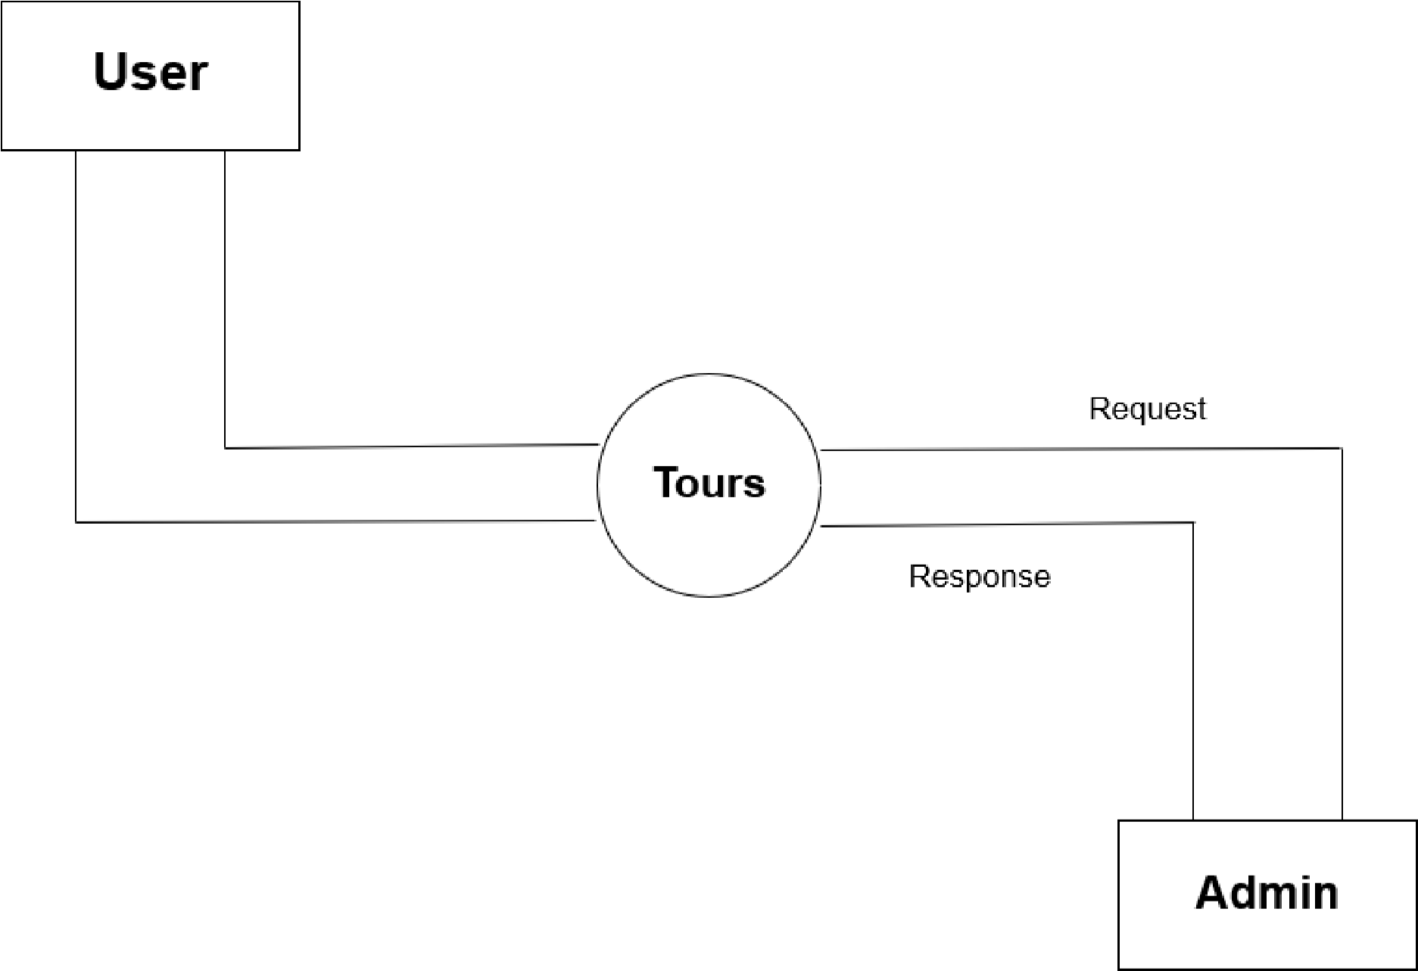

1)DFD 1 LEVEL(Client Side):-

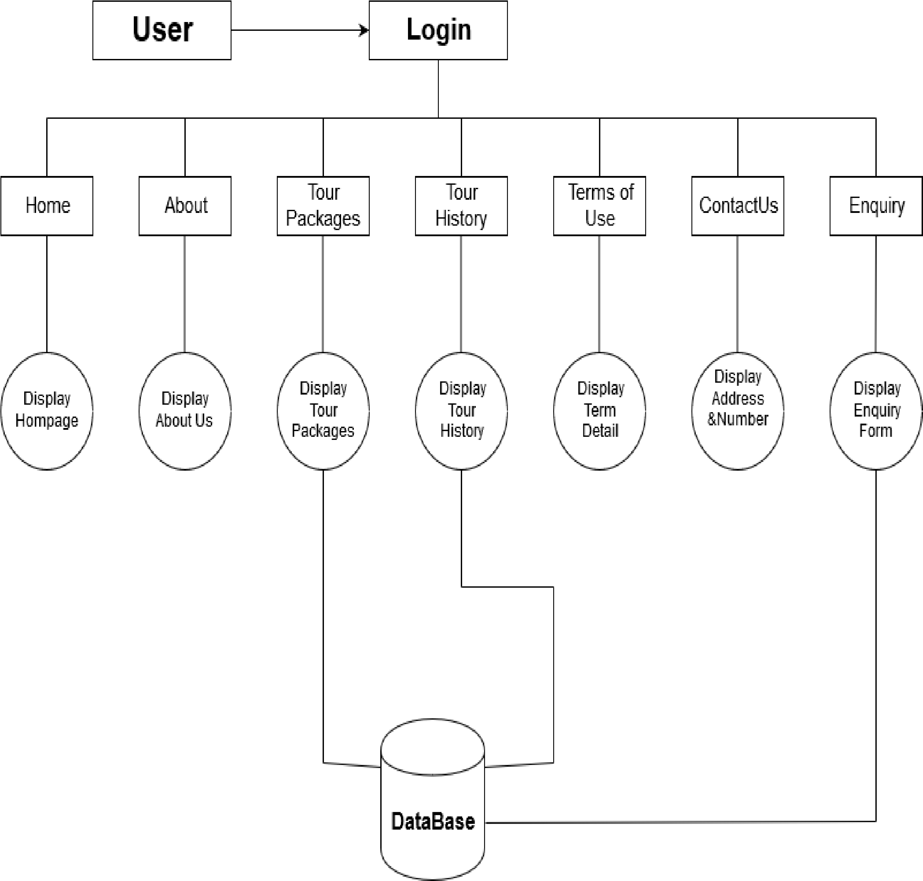

1)DFD 1 LEVEL(Admin Side):-

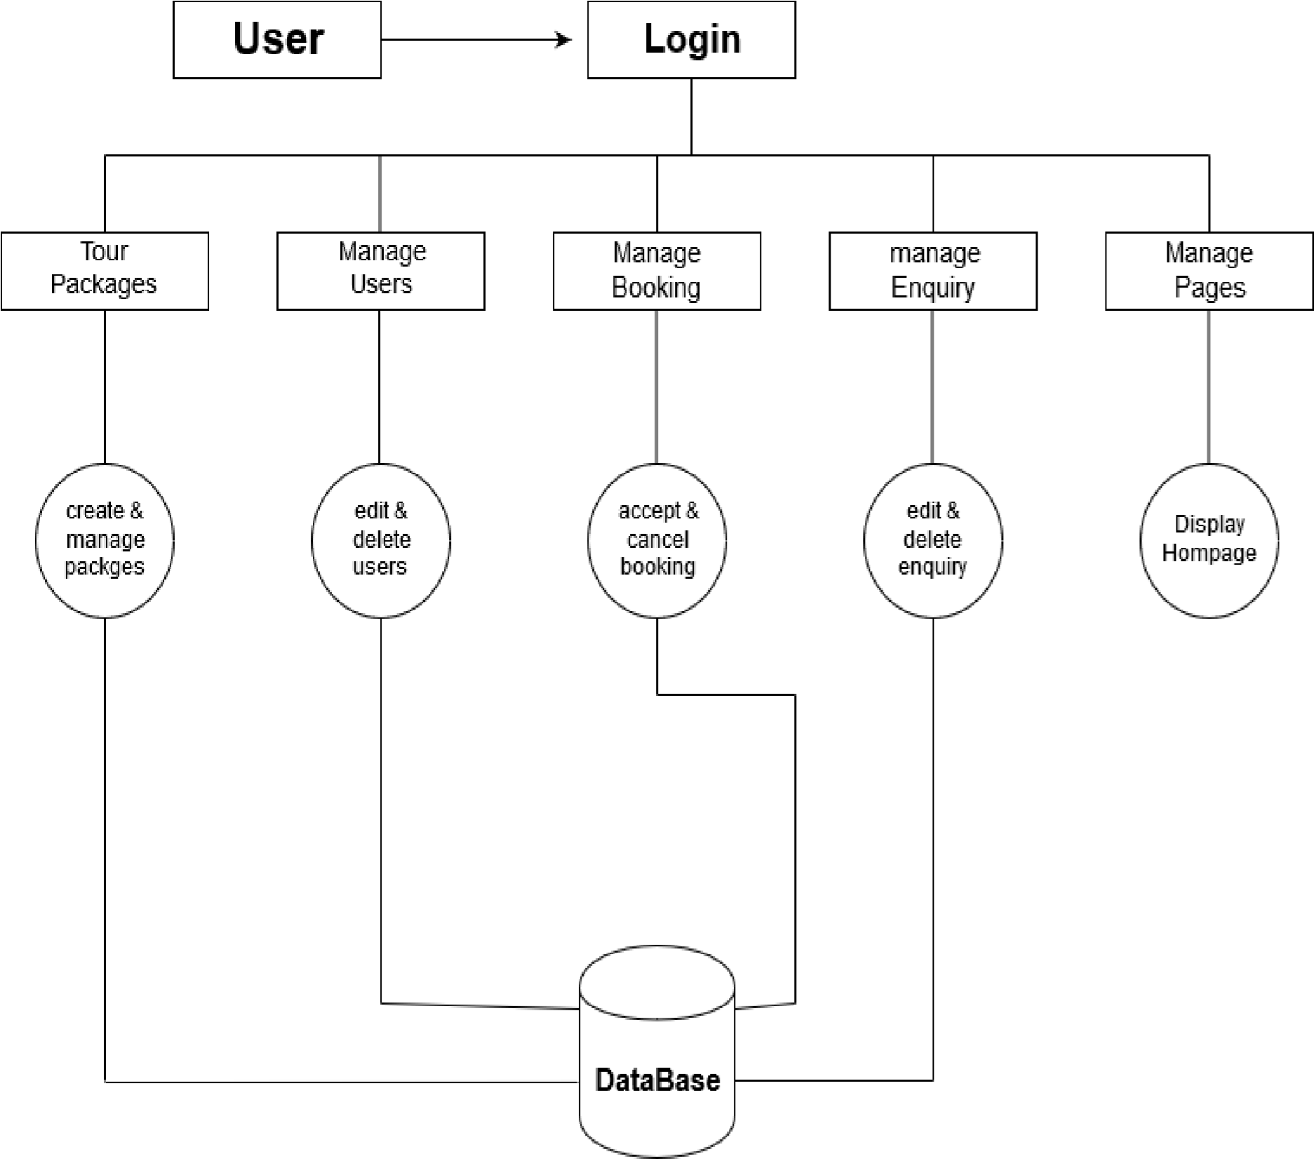

1)DFD 2 LEVEL(Client Side):-

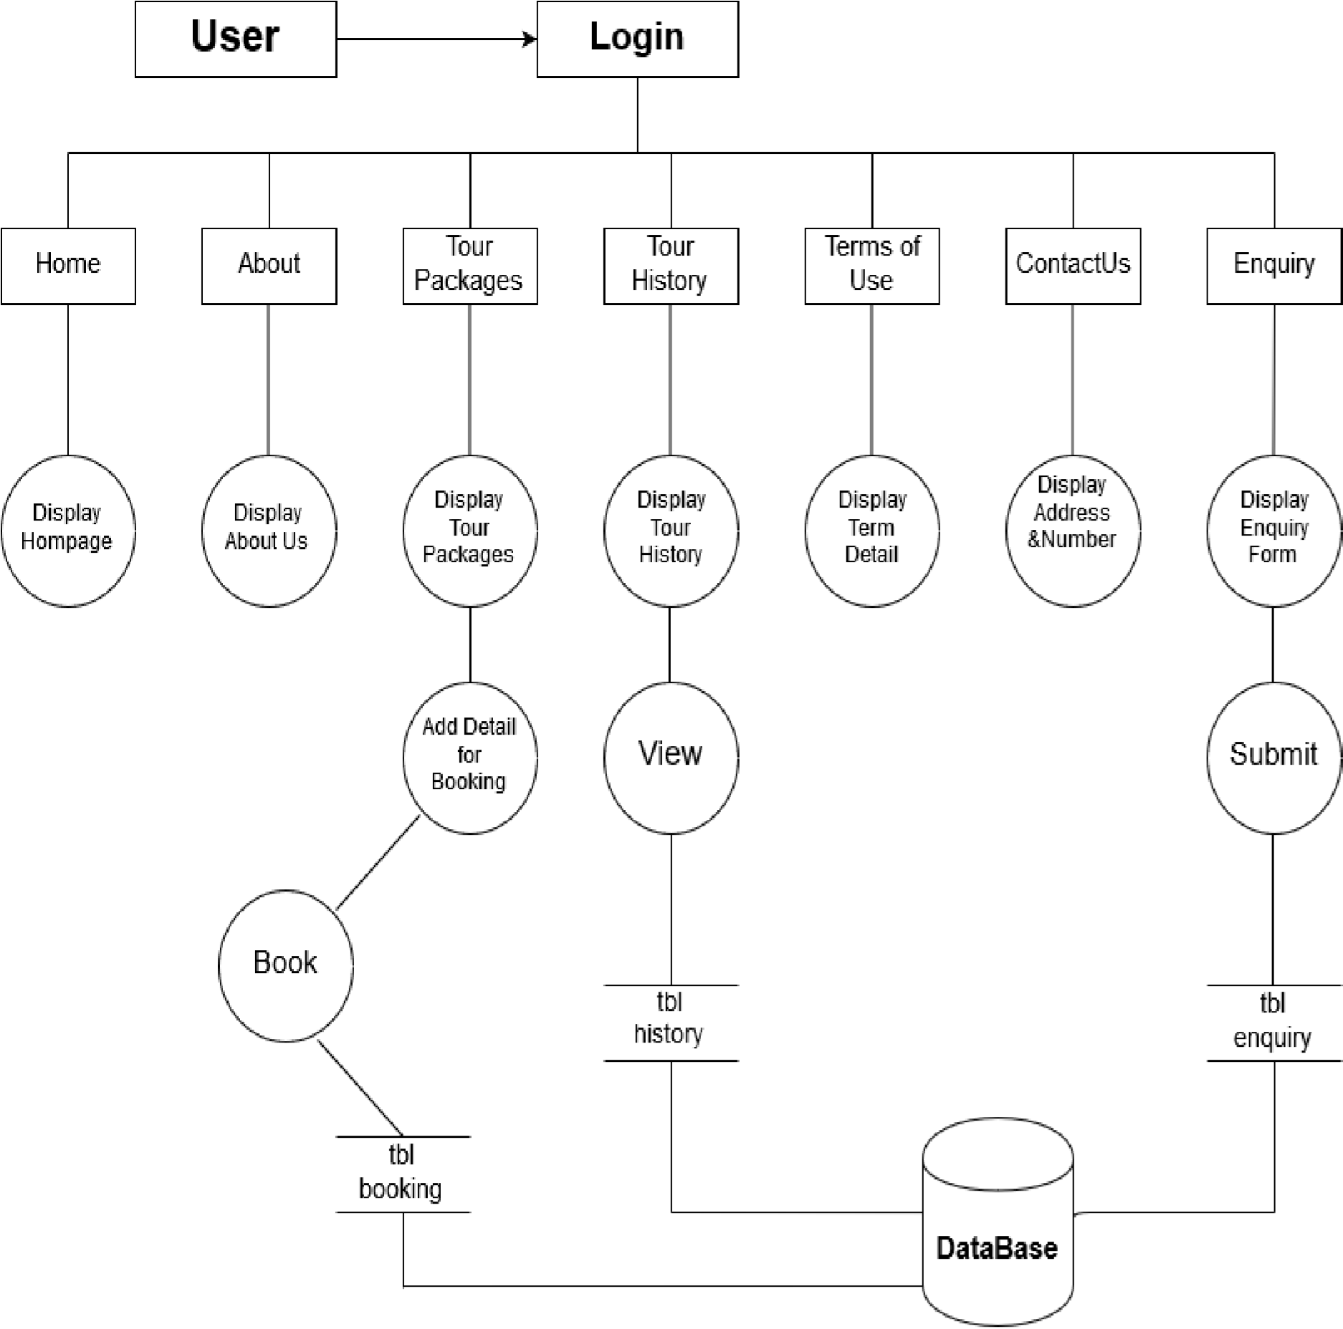

1)DFD 2 LEVEL(Admin Side):-

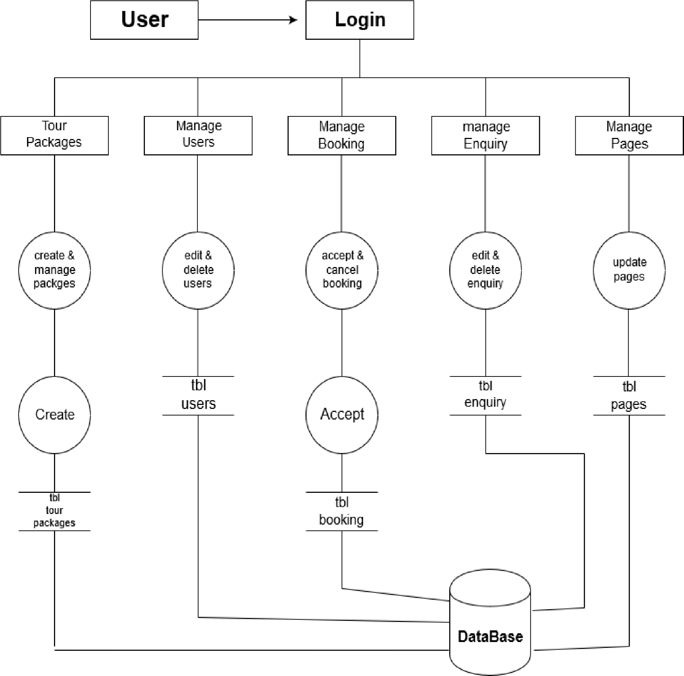

A PERT chart is a project management tool used to schedule, organize, and coordinate tasks within a project. PERT stands for Program Evaluation Review Technique. A similar methodology, the critical path method (CPM) was developed for project management in the private sector at about the same time.

The meaning of PERT is Project Estimation and

Review Techniques. PERT chart is a combination of various Arrows and Boxes indicating information.

There are various signs that describe their own meanings.

The box indicates various activities. So, when the boxes we see in the project we can decide that how the work is done into the various processes.

The arrow indicates the task dependencies on various processes. Arrows describes various task and in also shows that which task is dependent upon which task.

PERT chart is very useful to show the project statistically. PERT chart is also very useful in the project assuming. It also monitoring on the activities by the time. It takes the care of the process by timing.

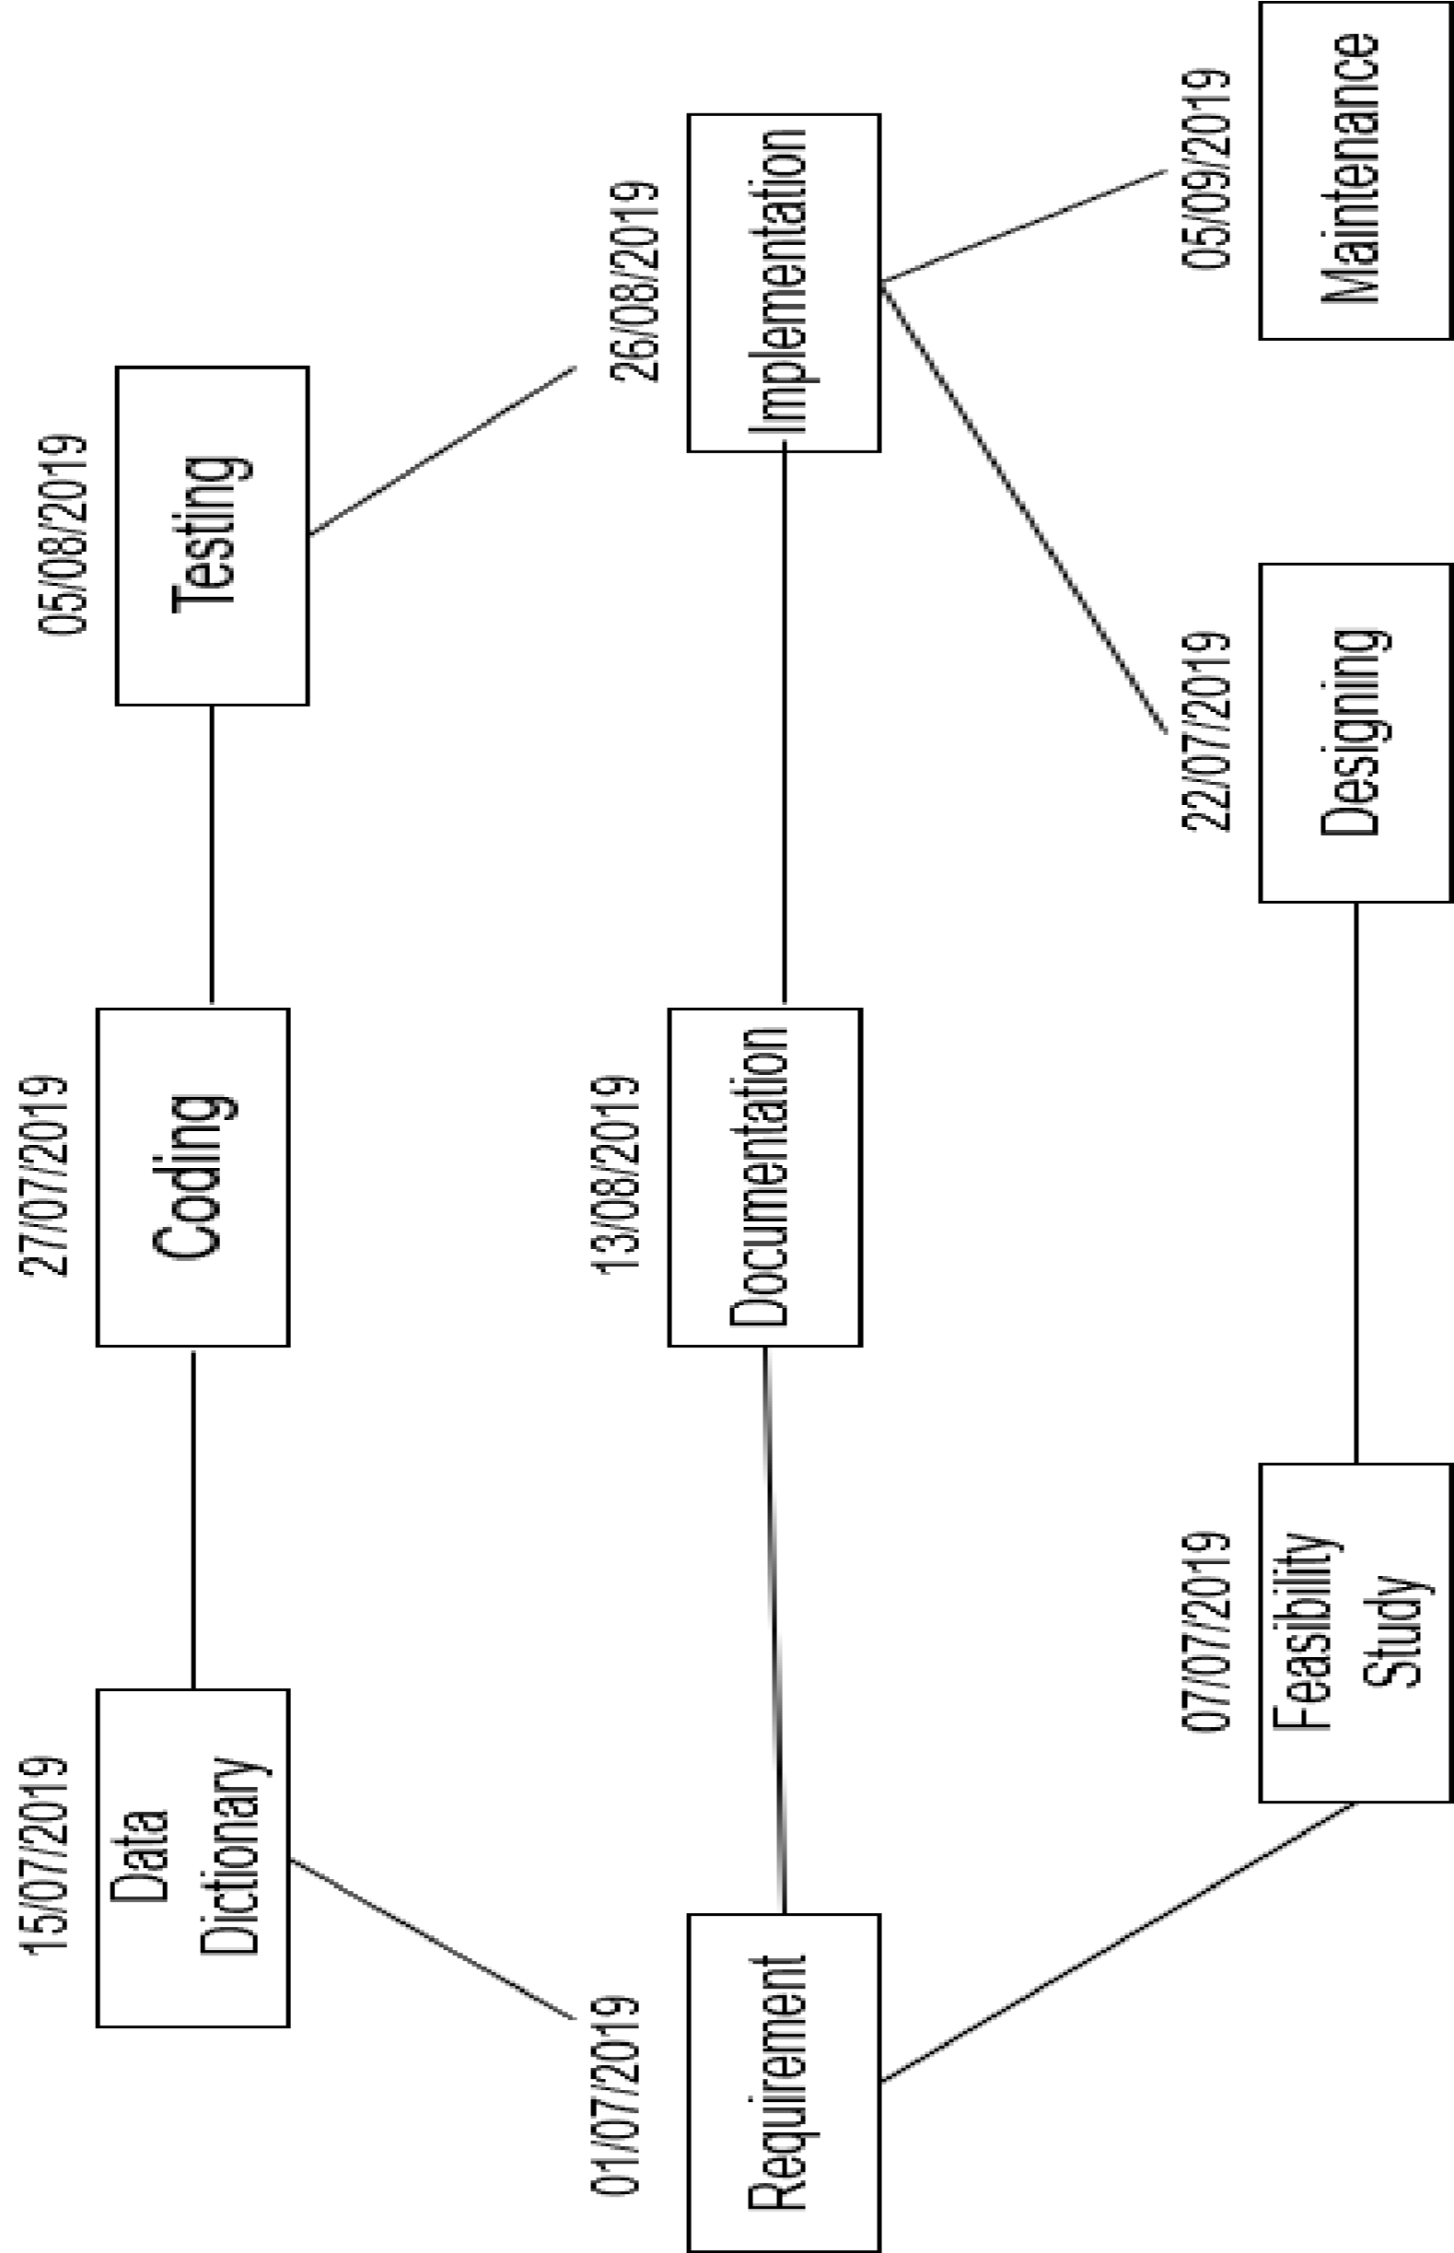

GANTT chart is a part of PERT chart and we can get many things of the Gantt chart via the PERT chart. GANTT chart describes very time scheduling & resource planning. When the more than one activity is done parallel this chart is very useful to understand the each process.

GANTT chart is a special type of bar-chart that describes that each bar describes a process or an activity. The length of the bar describes the time-allocated for the activity.

In GANTT chart each bar consists of two parts white part and shaded part. The shaded part indicates the length of time estimated for the process. The white part describes the slack part of the process. The white part also describes the time by that the process must be completed.

So we can say that the GANTT chart is most impotent part of repot because it describe total planning and estimation with date of our project.

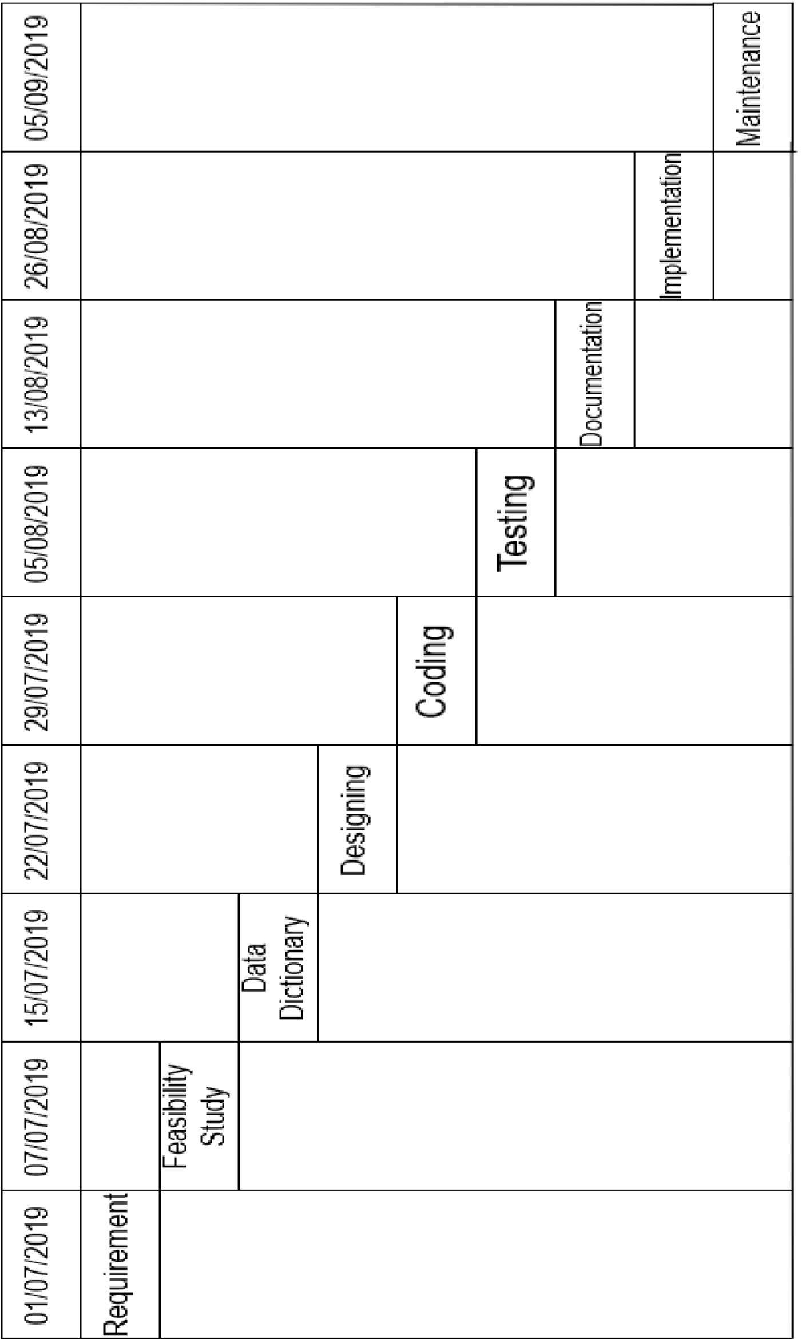

Testing



1. Black Box Testing:-

* + Black box testing to the admin side all queries is regularly implement and data store.
  + This type of the all functionally is a very higher And unique data.

1. White Box Testing:-

* + - White box testing to the client side any error of the show in admin.
    - This types of the client requirement of the all functionally and after then error of the regular data flow control is not verified.

1. Grey Box Testing:-

* + - Gerry box testing is a software testing technique that use a combination of black and white box testing technique.
    - Gerry box testing is not black box testing technique because the tester does no some of the internal working of the software under test in grey box testing the tester a plays a limited number of test cases to the grey box testing one tack a black box approach apply input to the software and test the output.

Screen layout of project and Coding index.php

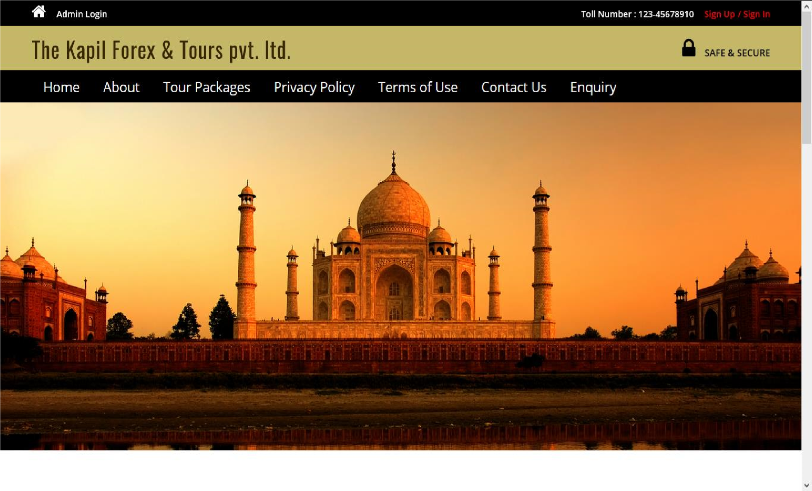

<?php session_start(); error_reporting(0); include('includes/config.php');

?>

<?php include('includes/header.php');?>

<?php $sql = "SELECT * from tbltourpackages order by rand() limit 4";

$query = $dbh->prepare($sql);

$query->execute();

$results=$query->fetchAll(PDO::FETCH_OBJ);

$cnt=1; if($query->rowCount() > 0)

{

foreach($results as $result)

{ ?>

<?php include('includes/footer.php');?>

<!-- signup -->

<?php include('includes/signup.php');?>

<!-- //signu -->

<!-- signin -->

<?php include('includes/signin.php');?>

<!-- //signin -->

<!-- write us -->

<?php include('includes/write-us.php');?>

<!-- //write us -->

Signup.php

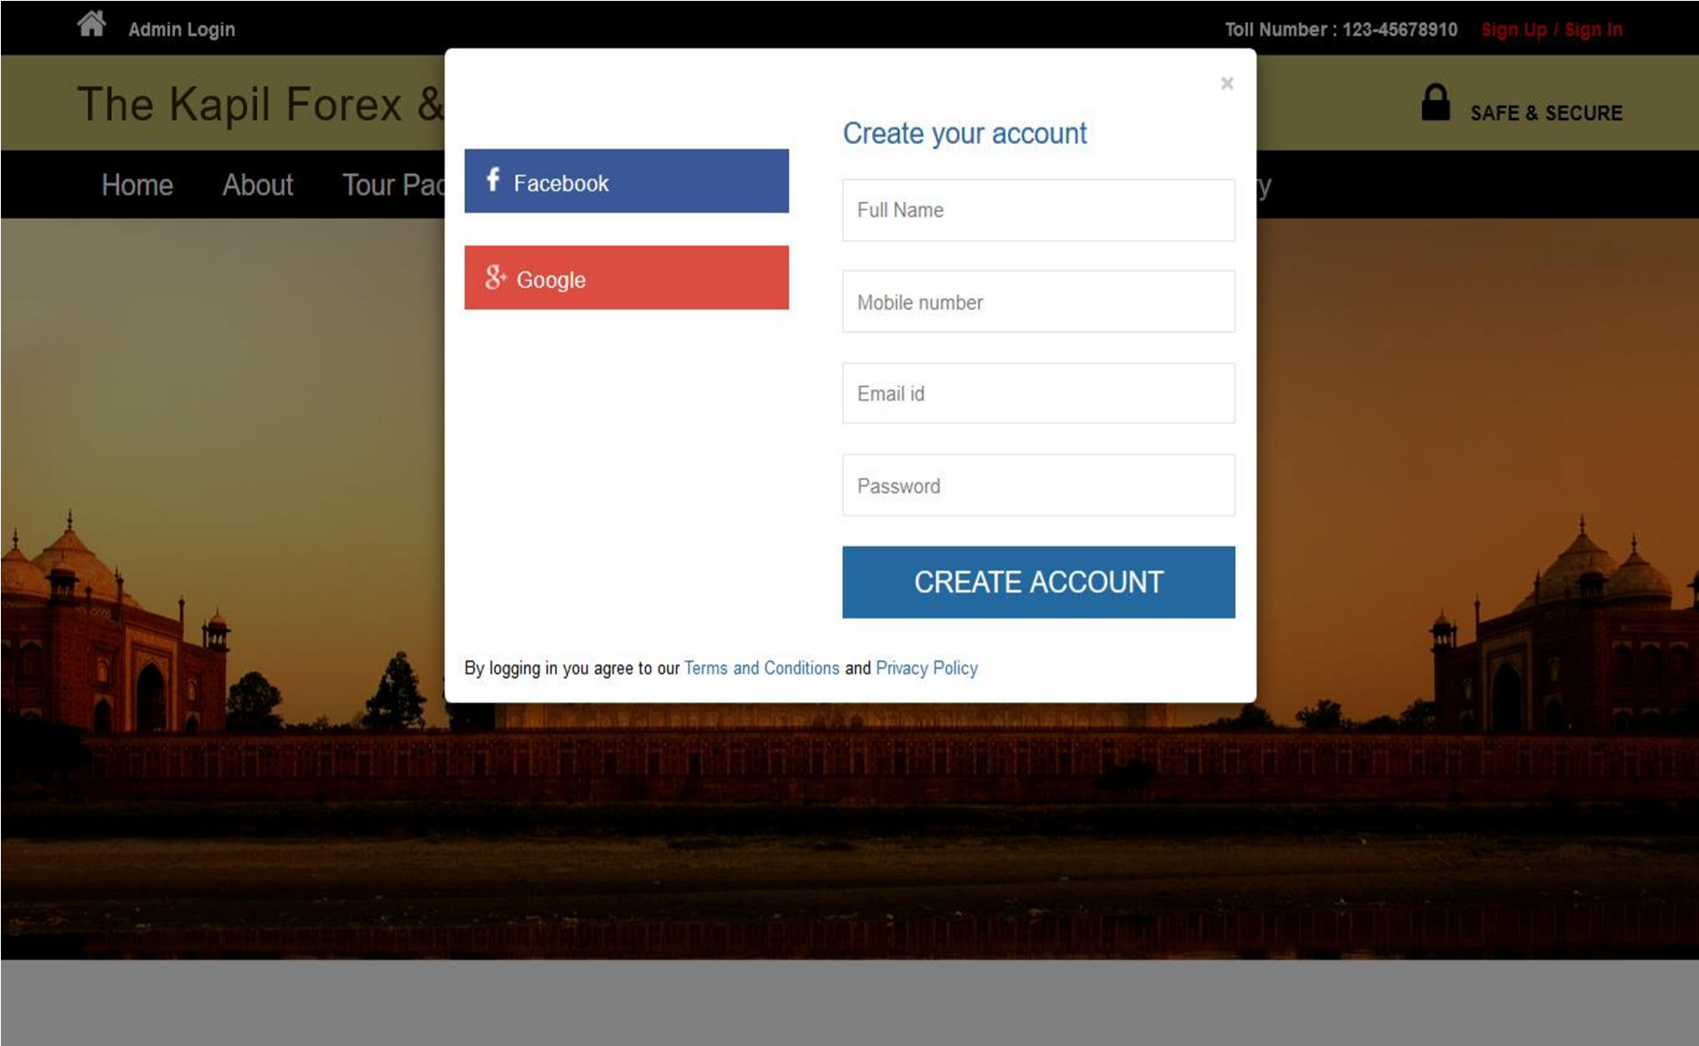

<?php

error_reporting(0); if(isset($_POST['submit']))

{

$fname=$_POST['fname'];

$mnumber=$_POST['mobilenumber'];

$email=$_POST['email'];

$password=md5($_POST['password']);

$sql="INSERT INTO tblusers(FullName,MobileNumber,EmailId,Password) VALUES(:fname,:mnumber,:email,:password)";

$query = $dbh->prepare($sql);

$query->bindParam(':fname',$fname,PDO::PARAM_STR);

$query->bindParam(':mnumber',$mnumber,PDO::PARAM_STR);

$query->bindParam(':email',$email,PDO::PARAM_STR);

$query->bindParam(':password',$password,PDO::PARAM_STR);

$query->execute();

$lastInsertId = $dbh->lastInsertId(); if($lastInsertId)

{

$_SESSION['msg']="You are Scuccessfully registered. Now you can login "; header('location:thankyou.php');

}

else

{

$_SESSION['msg']="Something went wrong. Please try again."; header('location:thankyou.php');

}

}

?>

<!--Javascript for check email availabilty-->

<script> function checkAvailability() {

$("#loaderIcon").show(); jQuery.ajax({ url: "check_availability.php", data:'emailid='+$("#email").val(), type: "POST", success:function(data){

$("#user-availability-status").html(data);

$("#loaderIcon").hide();

},

error:function (){}

});

}

</script>

signin.php

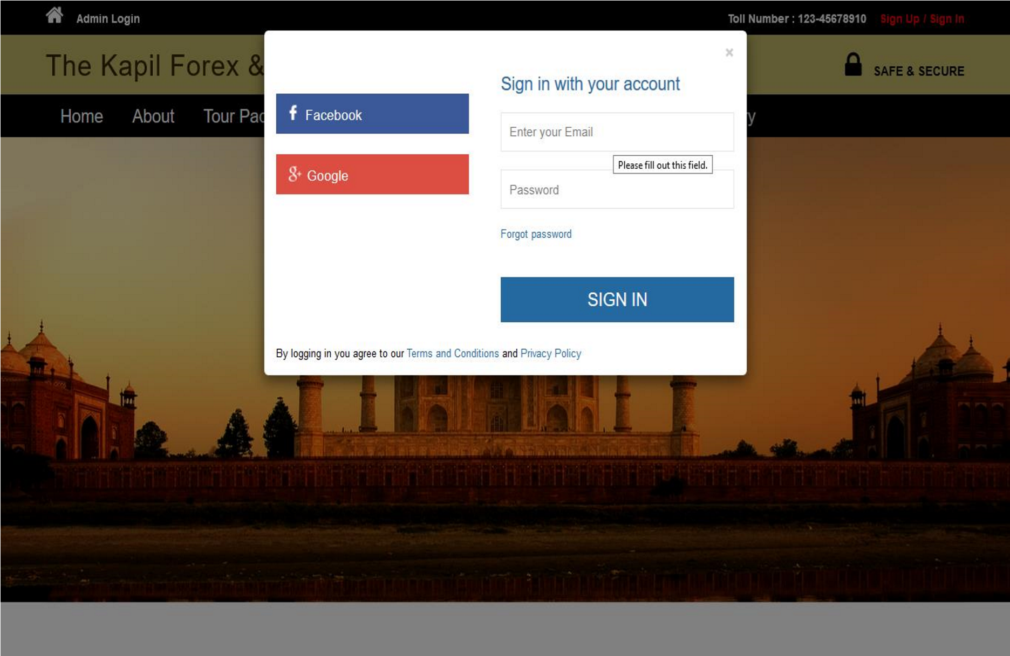

<?php session_start();

if(isset($_POST['signin']))

{

$email=$_POST['email'];

$password=md5($_POST['password']);

$sql ="SELECT EmailId,Password FROM tblusers WHERE EmailId=:email and Password=:password";

$query= $dbh -> prepare($sql);

$query-> bindParam(':email', $email, PDO::PARAM_STR);

$query-> bindParam(':password', $password, PDO::PARAM_STR);

$query-> execute();

$results=$query->fetchAll(PDO::FETCH_OBJ);

if($query->rowCount() > 0)

{

$_SESSION['login']=$_POST['email'];

echo "<script type='text/javascript'> document.location = 'package-list.php'; </script>"; } else{

echo "<script>alert('Invalid Details Please Enter Valid Details');</script>";

}

}

?>

aboutus.php

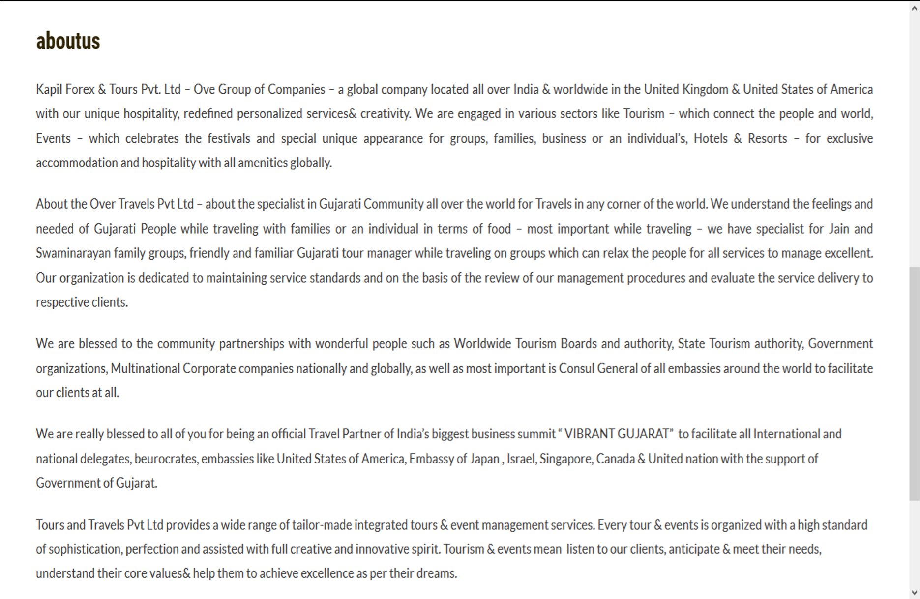

<?php session_start(); error_reporting(0); include('includes/config.php');

if(isset($_POST['submit1']))

{

$fname=$_POST['fname'];

$email=$_POST['email'];

$mobile=$_POST['mobileno'];

$subject=$_POST['subject'];

$description=$_POST['description'];

$sql="INSERT INTO tblenquiry(FullName,EmailId,MobileNumber,Subject,Description)

VALUES(:fname,:email,:mobile,:subject,:description)";

$query = $dbh->prepare($sql);

$query->bindParam(':fname',$fname,PDO::PARAM_STR);

$query->bindParam(':email',$email,PDO::PARAM_STR);

$query->bindParam(':mobile',$mobile,PDO::PARAM_STR); $query->bindParam(':subject',$subject,PDO::PARAM_STR);

$query->bindParam(':description',$description,PDO::PARAM_STR);

$query->execute();

$lastInsertId = $dbh->lastInsertId();

if($lastInsertId)

{

$msg="Enquiry Successfully submited";

}

else

{

$error="Something went wrong. Please try again";

}

}

?>

tourpackages.php

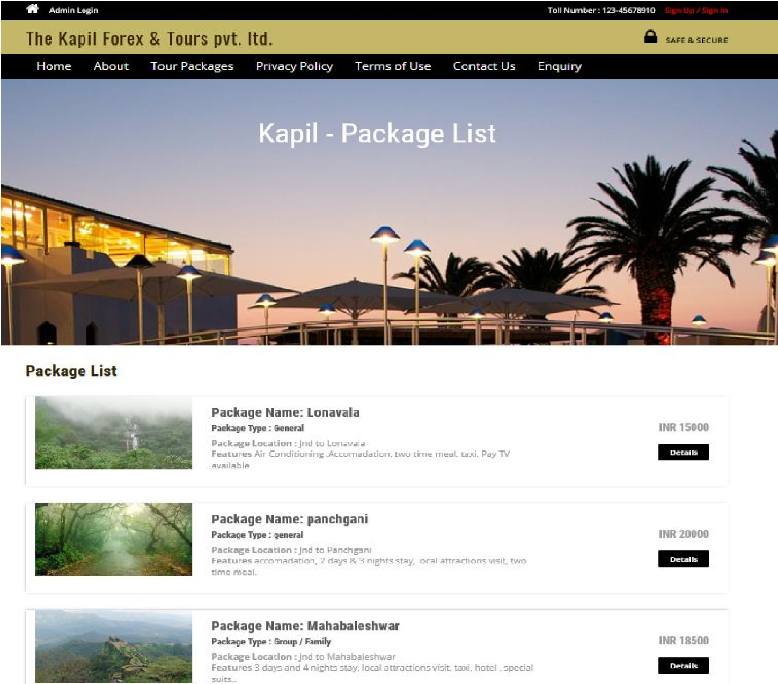

<?php session_start(); error_reporting(0); include('includes/config.php'); include('includes/header.php'); $sql = "SELECT * from tbltourpackages";

$query = $dbh->prepare($sql);

$query->execute();

$results=$query->fetchAll(PDO::FETCH_OBJ);

$cnt=1;

if($query->rowCount() > 0)

{

foreach($results as $result)

{

include('includes/footer.php'); include('includes/signup.php'); include('includes/signin.php');

include('includes/write-us.php');

?>

privacypolicy.php

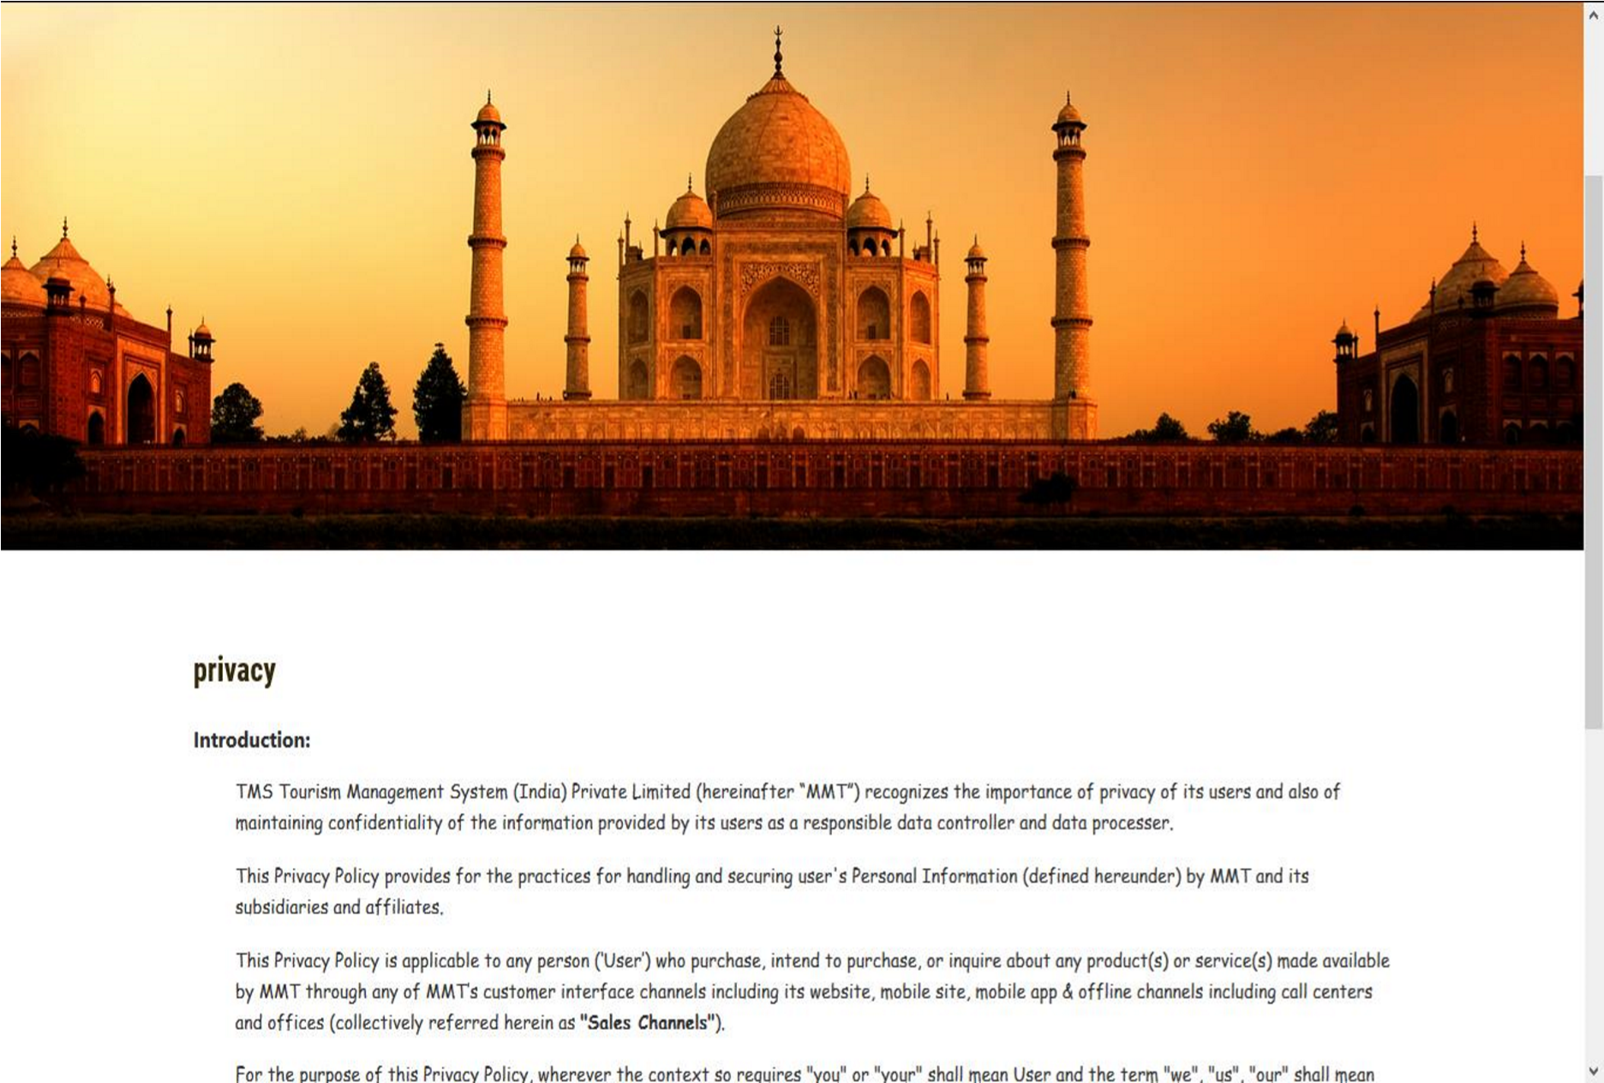

<?php session_start(); error_reporting(0); include('includes/config.php');

if(isset($_POST['submit1']))

{

$fname=$_POST['fname'];

$email=$_POST['email'];

$mobile=$_POST['mobileno'];

$subject=$_POST['subject'];

$description=$_POST['description'];

$sql="INSERT INTO tblenquiry(FullName,EmailId,MobileNumber,Subject,Description)

VALUES(:fname,:email,:mobile,:subject,:description)";

$query = $dbh->prepare($sql);

$query->bindParam(':fname',$fname,PDO::PARAM_STR);

$query->bindParam(':email',$email,PDO::PARAM_STR);

$query->bindParam(':mobile',$mobile,PDO::PARAM_STR);

$query->bindParam(':subject',$subject,PDO::PARAM_STR);

$query->bindParam(':description',$description,PDO::PARAM_STR);

$query->execute();

$lastInsertId = $dbh->lastInsertId();

if($lastInsertId)

{

$msg="Enquiry Successfully submited";

}

else

{

$error="Something went wrong. Please try again";

}

}

?>

termsofuse.php

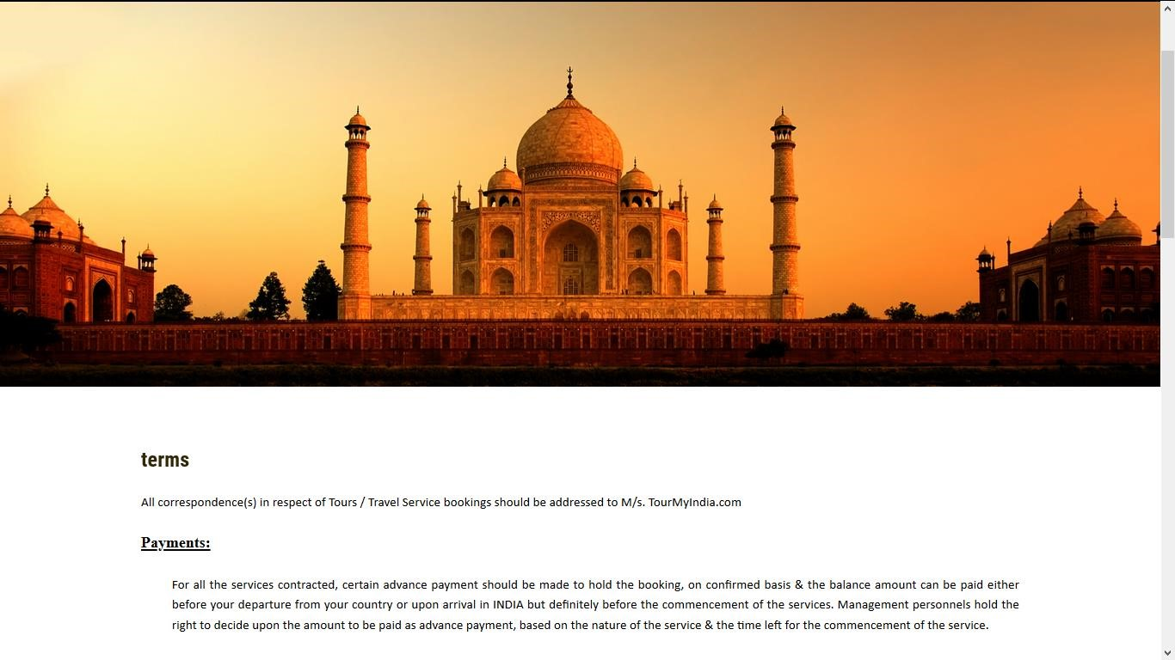

<?php session_start(); error_reporting(0); include('includes/config.php'); if(isset($_POST['submit1']))

{

$fname=$_POST['fname'];

$email=$_POST['email'];

$mobile=$_POST['mobileno'];

$subject=$_POST['subject'];

$description=$_POST['description'];

$sql="INSERT INTO tblenquiry(FullName,EmailId,MobileNumber,Subject,Description)

VALUES(:fname,:email,:mobile,:subject,:description)";

$query = $dbh->prepare($sql);

$query->bindParam(':fname',$fname,PDO::PARAM_STR);

$query->bindParam(':email',$email,PDO::PARAM_STR);

$query->bindParam(':mobile',$mobile,PDO::PARAM_STR);

$query->bindParam(':subject',$subject,PDO::PARAM_STR);

$query->bindParam(':description',$description,PDO::PARAM_STR);

$query->execute();

$lastInsertId = $dbh->lastInsertId();

if($lastInsertId)

{

$msg="Enquiry Successfully submited";

}

else

{

$error="Something went wrong. Please try again";

}

}

?>

enquiry.php

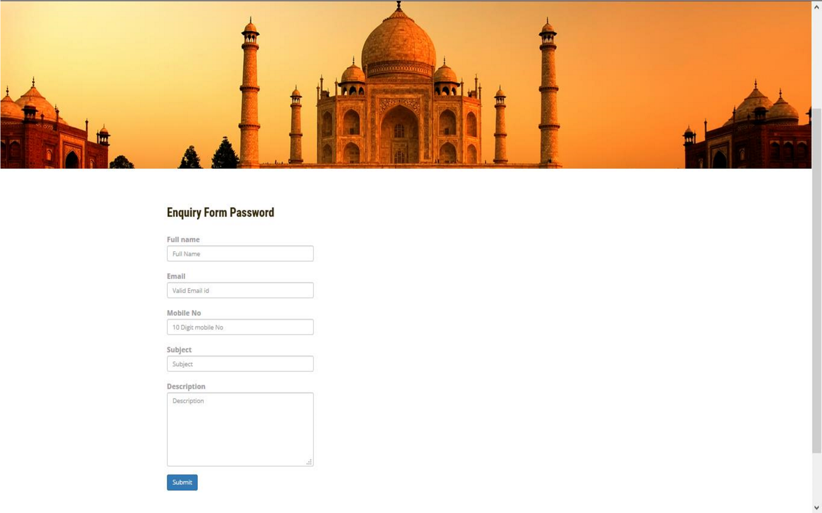

<?php session_start(); error_reporting(0); include('includes/config.php');

if(isset($_POST['submit1']))

{

$fname=$_POST['fname'];

$email=$_POST['email'];

$mobile=$_POST['mobileno'];

$subject=$_POST['subject'];

$description=$_POST['description'];

$sql="INSERT INTO tblenquiry(FullName,EmailId,MobileNumber,Subject,Description)

VALUES(:fname,:email,:mobile,:subject,:description)";

$query = $dbh->prepare($sql);

$query->bindParam(':fname',$fname,PDO::PARAM_STR);

$query->bindParam(':email',$email,PDO::PARAM_STR);

$query->bindParam(':mobile',$mobile,PDO::PARAM_STR);

$query->bindParam(':subject',$subject,PDO::PARAM_STR);

$query->bindParam(':description',$description,PDO::PARAM_STR);

$query->execute();

$lastInsertId = $dbh->lastInsertId();

if($lastInsertId)

{

$msg="Enquiry Successfully submited";

}

else

{

$error="Something went wrong. Please try again";

}

}

?>

<?php include('includes/footer.php');?>

<!-- signup -->

<?php include('includes/signup.php');?>

<!-- //signu -->

<!-- signin -->

<?php include('includes/signin.php');?>

<!-- //signin -->

<!-- write us -->

<?php include('includes/write-us.php');?>

adminlogin.php

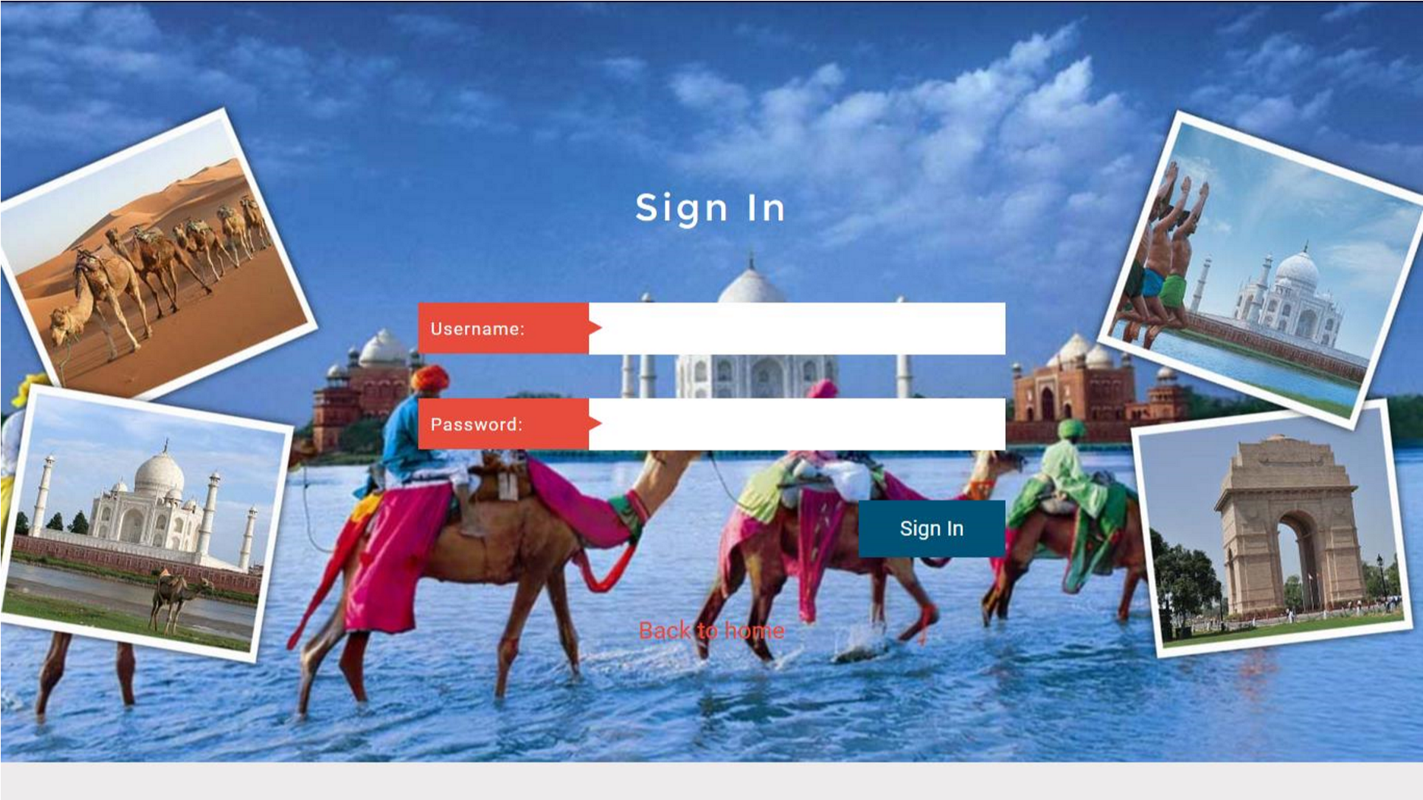

<?php session_start();

if(isset($_POST['signin']))

{

$email=$_POST['email'];

$password=md5($_POST['password']);

$sql ="SELECT EmailId,Password FROM tblusers WHERE EmailId=:email and Password=:password";

$query= $dbh -> prepare($sql);

$query-> bindParam(':email', $email, PDO::PARAM_STR);

$query-> bindParam(':password', $password, PDO::PARAM_STR);

$query-> execute();

$results=$query->fetchAll(PDO::FETCH_OBJ);

if($query->rowCount() > 0)

{

$_SESSION['login']=$_POST['email'];

echo "<script type='text/javascript'> document.location = 'package-list.php'; </script>"; } else{

echo "<script>alert('Invalid Details Please Enter Valid Details');</script>";

}

}

?>

dashboard.php

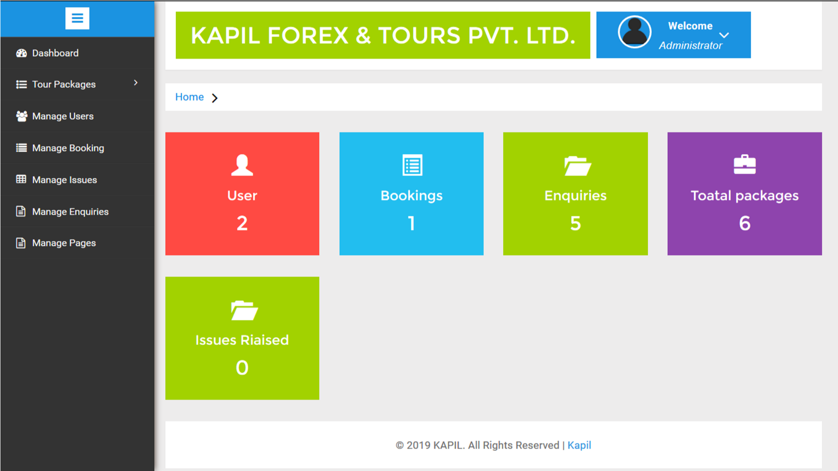

<?php session_start(); include('includes/config.php');

if(strlen($_SESSION['alogin'])==0)

{

header('location:index.php');

}

else{

?>

<?php include('includes/header.php');?>

<?php $sql = "SELECT id from tblusers";

$query = $dbh -> prepare($sql);

$query->execute();

$results=$query->fetchAll(PDO::FETCH_OBJ);

$cnt=$query->rowCount();

?>

$query1 = $dbh -> prepare($sql1);

$query1->execute();

$results1=$query1->fetchAll(PDO::FETCH_OBJ);

$cnt1=$query1->rowCount();

$query2= $dbh -> prepare($sql2);

$query2->execute();

$results2=$query2->fetchAll(PDO::FETCH_OBJ);

$cnt2=$query2->rowCount();

$query3= $dbh -> prepare($sql3);

$query3->execute();

$results3=$query3->fetchAll(PDO::FETCH_OBJ);

$cnt3=$query3->rowCount();

$(document).ready(function() {

//BOX BUTTON SHOW AND CLOSE

jQuery('.small-graph-box').hover(function() { jQuery(this).find('.box-button').fadeIn('fast');

}, function() {

jQuery(this).find('.box-button').fadeOut('fast');

});

jQuery('.small-graph-box .box-close').click(function() {

jQuery(this).closest('.small-graph-box').fadeOut(200);

return false;

});

//CHARTS

function gd(year, day, month) {

return new Date(year, month - 1, day).getTime();

}

graphArea2 = Morris.Area({ element: 'hero-area', padding: 10,

behaveLikeLine: true, gridEnabled: false, gridLineColor: '#dddddd',

axes: true, resize: true, smooth:true, pointSize: 0, lineWidth: 0, fillOpacity:0.85,

|  |  |  |  |  |
| --- | --- | --- | --- | --- |
|  |  |  | data: [ |  |
|  |  |  |  | {period: '2014 Q1', iphone: 2668, ipad: null, itouch: 2649}, |
|  |  |  |  | {period: '2014 Q2', iphone: 15780, ipad: 13799, itouch: 12051}, |
|  |  |  |  | {period: '2014 Q3', iphone: 12920, ipad: 10975, itouch: 9910}, |
|  |  |  |  | {period: '2014 Q4', iphone: 8770, ipad: 6600, itouch: 6695}, |
|  |  |  |  | {period: '2015 Q1', iphone: 10820, ipad: 10924, itouch: 12300}, |
|  |  |  |  | {period: '2015 Q2', iphone: 9680, ipad: 9010, itouch: 7891}, |
|  |  |  |  | {period: '2015 Q3', iphone: 4830, ipad: 3805, itouch: 1598}, |
|  |  |  |  | {period: '2015 Q4', iphone: 15083, ipad: 8977, itouch: 5185}, |
|  |  |  |  | {period: '2016 Q1', iphone: 10697, ipad: 4470, itouch: 2038}, |
|  |  |  |  | {period: '2016 Q2', iphone: 8442, ipad: 5723, itouch: 1801} |
|  |  |  | ], |  |
|  |  |  | lineColors:['#ff4a43','#a2d200','#22beef'], | |
|  |  |  | xkey: 'period', | |

redraw: true,

ykeys: ['iphone', 'ipad', 'itouch'],

labels: ['All Visitors', 'Returning Visitors', 'Unique Visitors'],

pointSize: 2, hideHover: 'auto',

resize: true

});

});

</script>

Createpackage.php

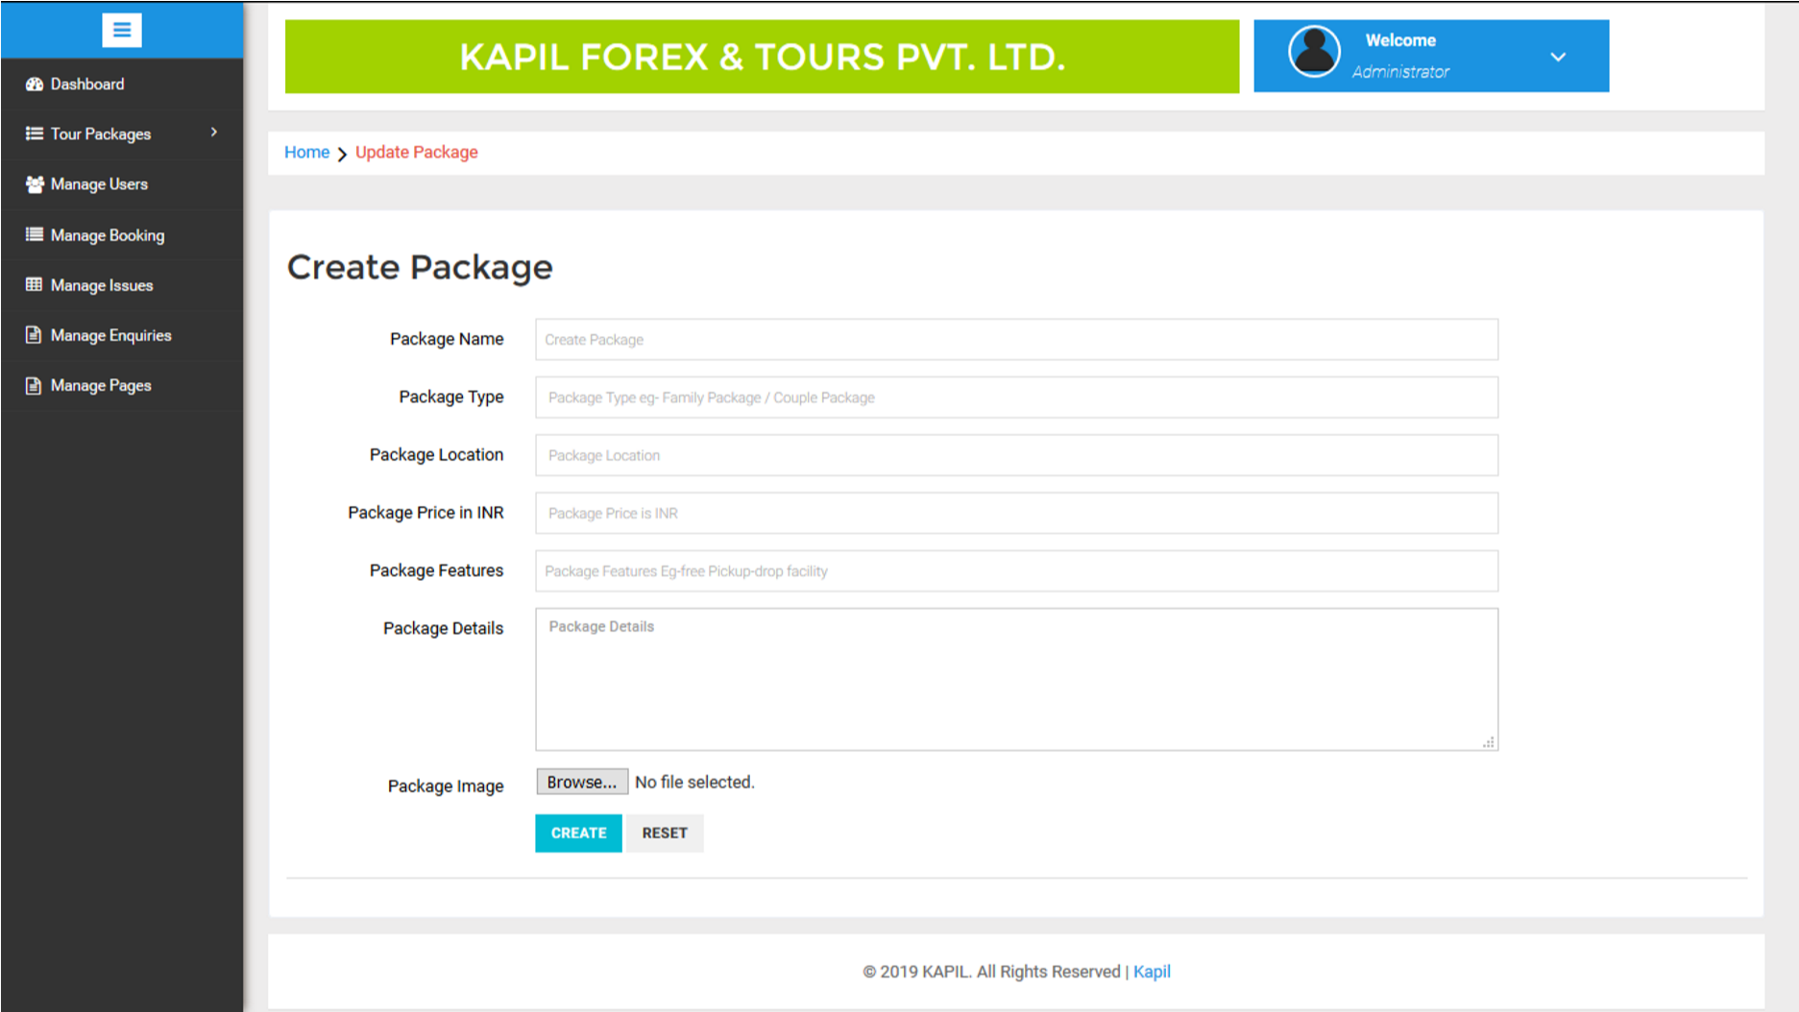

<?php

session_start(); error_reporting(0); include('includes/config.php');

if(strlen($_SESSION['alogin'])==0)

{

header('location:index.php');

}

else{

$pid=intval($_GET['pid']); if(isset($_POST['submit']))

{

$pname=$_POST['packagename'];

$ptype=$_POST['packagetype'];

$plocation=$_POST['packagelocation'];

$pprice=$_POST['packageprice'];

$pfeatures=$_POST['packagefeatures'];

$pdetails=$_POST['packagedetails'];

$pimage=$_FILES["packageimage"]["name"];

$sql="update TblTourPackages set

PackageName=:pname,PackageType=:ptype,PackageLocation=:plocation,PackagePrice=:pprice,Package Fetures=:pfeatures,PackageDetails=:pdetails where PackageId=:pid";

$query = $dbh->prepare($sql);

$query->bindParam(':pname',$pname,PDO::PARAM_STR);

$query->bindParam(':ptype',$ptype,PDO::PARAM_STR);

$query->bindParam(':plocation',$plocation,PDO::PARAM_STR);

$query->bindParam(':pprice',$pprice,PDO::PARAM_STR);

$query->bindParam(':pfeatures',$pfeatures,PDO::PARAM_STR);

$query->bindParam(':pdetails',$pdetails,PDO::PARAM_STR); $query->bindParam(':pid',$pid,PDO::PARAM_STR);

$query->execute();

$msg="Package Updated Successfully";

}

?>

manageuser.php

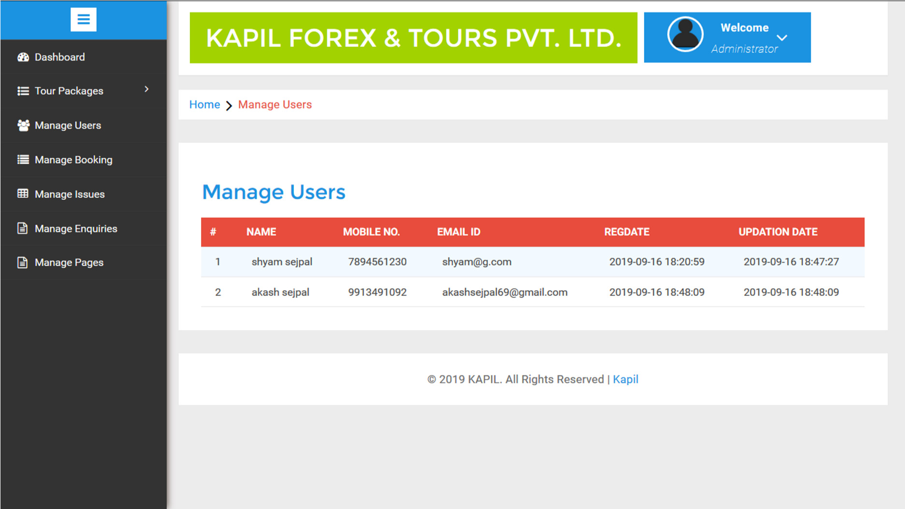

<?php session_start(); error_reporting(0); include('includes/config.php');

if(strlen($_SESSION['alogin'])==0)

{

header('location:index.php');

}

else{

?>

<?php include('includes/header.php');?>

<?php $sql = "SELECT * from tblusers";

$query = $dbh -> prepare($sql);

$query->execute();

$results=$query->fetchAll(PDO::FETCH_OBJ);

$cnt=1;

if($query->rowCount() > 0)

{

foreach($results as $result)

<?php include('includes/sidebarmenu.php');?>

managebooking.php

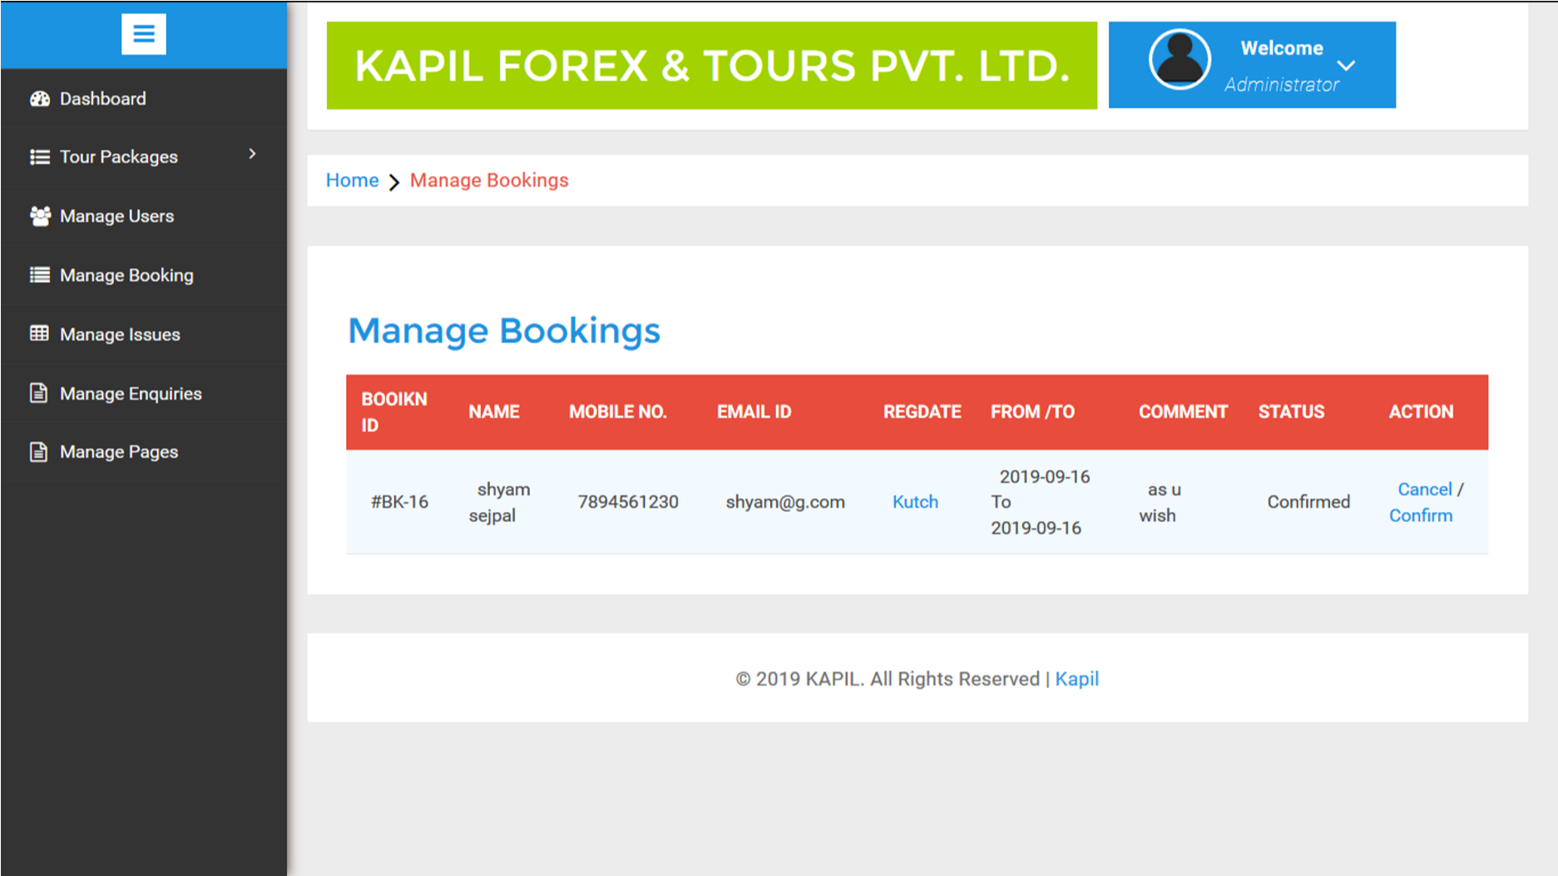

<?php session_start(); error_reporting(0); include('includes/config.php');

if(strlen($_SESSION['alogin'])==0)

{

header('location:index.php');

}

else{

// code for cancel

if(isset($_REQUEST['bkid']))

{

$bid=intval($_GET['bkid']);

$status=2;

$cancelby='a';

$sql = "UPDATE tblbooking SET status=:status,CancelledBy=:cancelby WHERE BookingId=:bid"; $query = $dbh->prepare($sql);

$query -> bindParam(':status',$status, PDO::PARAM_STR);

$query -> bindParam(':cancelby',$cancelby , PDO::PARAM_STR);

$query-> bindParam(':bid',$bid, PDO::PARAM_STR);

$query -> execute();

$msg="Booking Cancelled successfully";

}

if(isset($_REQUEST['bckid']))

{

$bcid=intval($_GET['bckid']);

$status=1;

$cancelby='a';

$sql = "UPDATE tblbooking SET status=:status WHERE BookingId=:bcid";

$query = $dbh->prepare($sql);

$query -> bindParam(':status',$status, PDO::PARAM_STR);

$query -> bindParam(':bcid',$bcid, PDO::PARAM_STR);

$query -> execute();

$msg="Booking Confirm successfully";

}

<?php $sql = "SELECT tblbooking.BookingId as bookid,tblusers.FullName as fname,tblusers.MobileNumber as mnumber,tblusers.EmailId as email,tbltourpackages.PackageName as pckname,tblbooking.PackageId as pid,tblbooking.FromDate as fdate,tblbooking.ToDate as tdate,tblbooking.Comment as comment,tblbooking.status as status,tblbooking.CancelledBy as cancelby,tblbooking.UpdationDate as upddate from tblusers join tblbooking on tblbooking.UserEmail=tblusers.EmailId join tbltourpackages on tbltourpackages.PackageId=tblbooking.PackageId";

$query = $dbh -> prepare($sql);

$query->execute();

$results=$query->fetchAll(PDO::FETCH_OBJ);

$cnt=1;

if($query->rowCount() > 0)

{

foreach($results as $result)

{?>

?>

<?php include('includes/sidebarmenu.php');?>

manageenquiry.php

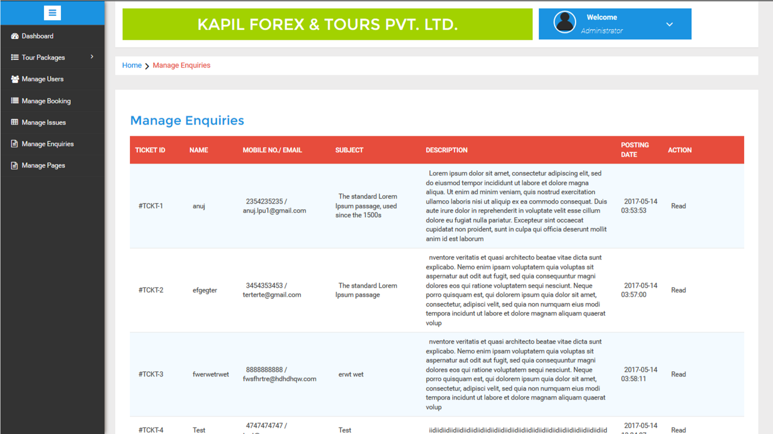

<?php session_start(); error_reporting(0); include('includes/config.php');

if(strlen($_SESSION['alogin'])==0)

{

header('location:index.php');

}

else{

// code for cancel

if(isset($_REQUEST['eid']))

{

$eid=intval($_GET['eid']);

$status=1;

$sql = "UPDATE tblenquiry SET Status=:status WHERE id=:eid";

$query = $dbh->prepare($sql);

$query -> bindParam(':status',$status, PDO::PARAM_STR);

$query-> bindParam(':eid',$eid, PDO::PARAM_STR);

$query -> execute();

$msg="Enquiry successfully read";

}

<?php $sql = "SELECT * from tblenquiry";

$query = $dbh -> prepare($sql);

$query->execute();

$results=$query->fetchAll(PDO::FETCH_OBJ);

if($query->rowCount() > 0)

{

foreach($results as $result)

{ ?>

managepages.php

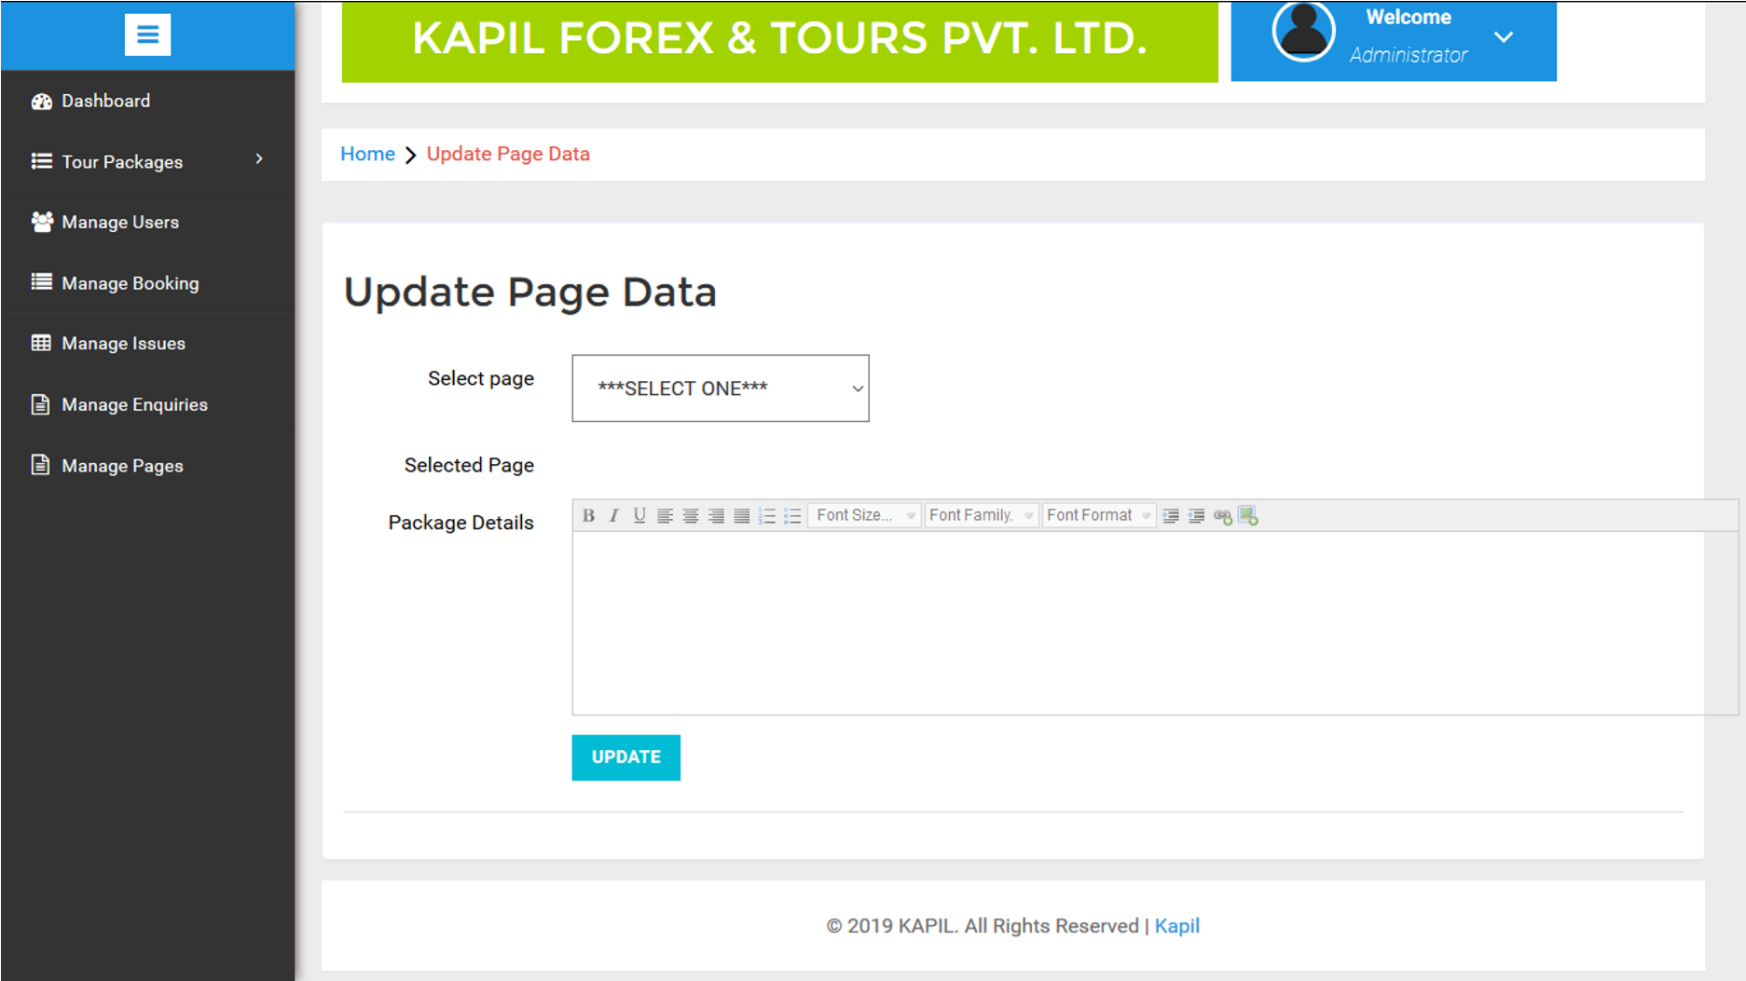

<?php session_start(); error_reporting(0); include('includes/config.php');

if(strlen($_SESSION['alogin'])==0)

{

header('location:index.php');

}

else{

if($_POST['submit']=="Update")

{

$pagetype=$_GET['type'];

$pagedetails=$_POST['pgedetails'];

$sql = "UPDATE tblpages SET detail=:pagedetails WHERE type=:pagetype";

$query = $dbh->prepare($sql);

$query -> bindParam(':pagetype',$pagetype, PDO::PARAM_STR);

$query-> bindParam(':pagedetails',$pagedetails, PDO::PARAM_STR);

$query -> execute();

$msg="Page data updated successfully";

}

?>

$pagetype=$_GET['type'];

$sql = "SELECT detail from tblpages where type=:pagetype";

$query = $dbh -> prepare($sql);

$query->bindParam(':pagetype',$pagetype,PDO::PARAM_STR);

$query->execute();

$results=$query->fetchAll(PDO::FETCH_OBJ);

$cnt=1;

if($query->rowCount() > 0)

{

foreach($results as $result){echo htmlentities($result->detail}}

BIBLOGRAPHY

Following is a list of References which Books or software We have used in our project.

* Reference Books:-

• PhP & MySql Web Devlopment

* Other References:-

▪ [www.w3school.com](http://www.w3school.com/)

* + [www.google.com](http://www.google.com/)

* + www.youtube.com